What is Open Science?

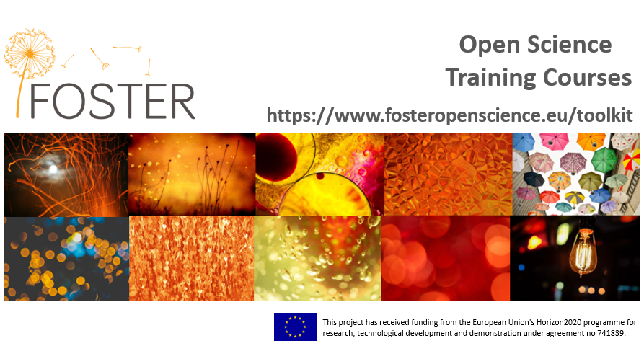
The FOSTER taxonomy defines Open Science as the movement to make scientific research, data and dissemination accessible to all levels of an inquiring society.
Sounds good but what does Open Science (OS) mean in a practical sense? FOSTER’s ten Open Science courses answer some of the most common questions you might have about putting open science into practice. Each course takes about 1-2 hours to work through and you’ll receive a badge upon completion. The courses include practical tips on getting started with OS as well as providing information on discipline specific tools and resources you can use. There is no specified order through the courses – just explore topics that you want to learn more about at your own pace.

 | What is Open Science?  Print version: 10.5281/zenodo.2629946  Online version: https://www.fosteropenscience.eu/node/2326

This introductory course will help you to understand what open science is and why it is something you should care about

Overview

This introductory course will help you to understand what open science is and why it is something you should care about. You'll get to grips with the expectations of research funders and will learn how practising aspects of open science can benefit your career progression. Upon completing this course, you will:

- understand what Open Science means and why you should care about it
- be aware of some of the different ways to go about making your own research more open over the research lifecycle
- understand why funding bodies are in support of Open Science and what their basic requirements are
- be aware of the potential benefits of practicing open science

It is important to remember that Open Science is not different to traditional science. It just means that you carry out your research in a more transparent and collaborative way. Open Science applies to all research disciplines. While Open Science is the most commonly used term, you may also hear people talking about Open Scholarship or Open Research in the Arts and Humanities.

What is Open Science?

What? FOSTER defines Open Science (OS) as the practice of science in such a way that others can collaborate and contribute, where research data, lab notes and other research processes are freely available, under terms that enable reuse, redistribution and reproduction of the research and its underlying data and methods.
Image CC-BY-NC-SA by Tom Magllery https://flic.kr/p/4FUTKA

Why? Opening the research process supports validation, reproducibility and reduces cases of academic misconduct. It helps to maximise the impact of your research and provides the foundations for others to build upon. In short, applying open science in your daily workflows is just part of good research practice!

For more on the basics of Open Science, check out this short video by Ivo Grigorov, Technical University of Denmark (DTU) introduces the concepts of Open Science and explains how they should be applied over the entire research lifecycle.

Open Science - more than just open access to publications!

Publishing in Open Access journals is great but there is more to practicing Open Science. As an Open Science practitioner, you should also:


Share your data - the research data that underpins publications should also be accessible to support validation and facilitate reuse. In cases where data sensitivities won't allow open access, be sure to provide details on how someone could request authorised access.

Share your code - many researchers now develop bespoke bits of code to help them analyse and/or visualise the data they have collected. Having access to this code is essential for supporting the validation of your findings and to help others to build upon your work.
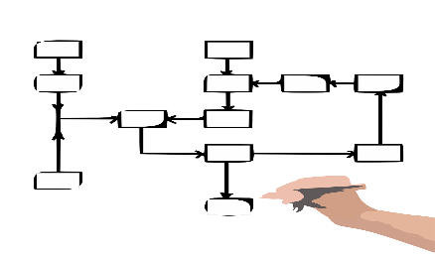
Share your workflows - without knowing what steps were taken to capture, process and analyse the data - and in what order - it can be virtually impossible to validate published findings. This has led to what some are calling the Reproducibility Crisis. Nature's special issue on Challenges in Irreproducible Research gives you a better sense of the scale of this problem.

Four pillars of Open Science: putting OS into practice

Open Science is about making research findings accessible to all rather than keeping them locked away behind a paywall. Open Science is based on key principles. These principles are explored in Do You Speak Open Science? Resources and Tips to Learn the Language.

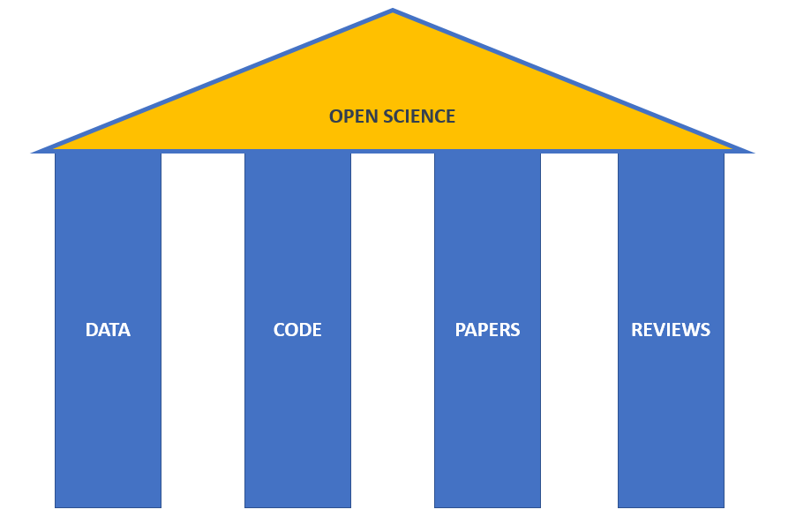
Data-driven research is fast becoming the norm in all disciplines. To support validation of your findings and allow others to build upon your work, you first need to make sure that others can find your data. This means giving them unique identifiers (such as DOIs); putting them into a repository that supports public searching; and being clear about what others can and can't do with them by applying an appropriate license. Check out our course on managing and sharing research data for more information. To find the right license for your outputs, check out our open licensing course.
When sharing your software and code, be sure to make use of open source standards to support interoperability and their longer-term viability. Be sure to put your code somewhere that others can search for it and access it (e.g., Github). You should also be clear about the license the code is being shared under. Learn more about looking after your code in our course covering open source software and workflows. Our course on open licensing will help you to find the best option for your software outputs.
Open Access to papers and publications is a key component of Open Science. Free and instant access to publications improves the speed of innovation and leads better cooperation and progress in solving grand challenges. To publish openly, you'll need to be able to source an appropriate OA journal or discipline specific repository and navigate your way through their publishing agreements. You should also consider sharing preprints of your work as a means of getting early feedback and community validation of your approaches. In some cases, you'll need to pay an Article Processing Charge to publish in an OA journal. Learn more about these issues in our Open Access publishing course.
The peer review process is evolving. By making the peer review process more transparent, researchers have better access to peer feedback at an earlier stage in the lifecycle and consumers of research outputs can have greater confidence in their quality. Learn more about how this in our open peer review (OPR) course.

What can you do? Open Science opportunities at a glance

As you can see in the diagram below, there are opportunities at every stage of the research lifecycle to open up your work and get others actively involved.

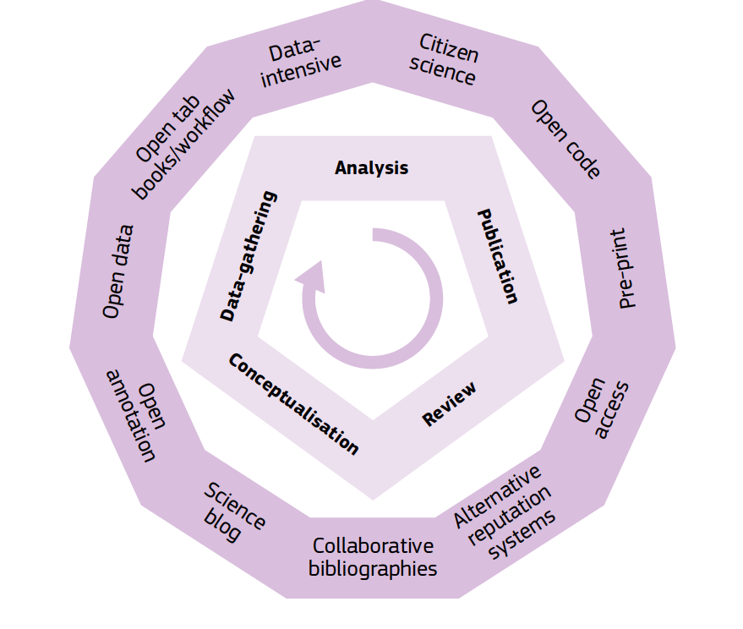
Image - European Commission Public Consultation Science 2.0: Science in Transition

Ideas for opening up during each stage of your research

During the planning stage
You might want to consider writing a blog post outlining your ideas and approaches early on to get community feedback. In addition to seeking involvement from other researchers, be sure to consider involving other stakeholders too. For instance, seeking collaboration with industrial partners at the idea stage can be a great way to see your research outputs applied in a real life setting more quickly. That is great for your impact!

Be sure to check data repositories to see if there are existing data that you can reuse or build upon during your research rather than starting from scratch. re3data is a great way to find relevant repositories for your area of research. As you can see from the screenshot below, re3data provides access to repositories across a very wide range of subjects. There are more than 600 repositories listed for the Humanities and Social Sciences and more than 1000 for the Life Sciences - each of which allows users to search more specifically by sub-domain. Reusing data means you ask for less public money in your proposal (reviewers generally like this!) and gives you the potential to identify any gaps that targeted data collection could help to fill.

During the active stage
You might share your methodologies and early findings via preprints. This is a great way to get peer feedback early on and helps you to identify any errors or problems with your approach before you publish.

Worried about getting scooped if you share early? Pre-registering your study gives you time-stamped evidence of your ideas. In addition, any peers that review your early work can vouch for you. This Open Science Framework (OSF) guide offers great advice on pre-registering your project.

You may want to involve citizen science in analysing the data you have generated or collected. This can dramatically increase the amount of data that you can realistically analyse in a short space of time and meaningful public engagement (i.e., not just a box-ticking exercise) is generally viewed very favourably by grant application reviewers. Check out Zooniverse's tips for setting up your own citizen science project.

Towards the end of your research
Make sure to publish with an Open Access journal and/or to deposit your publications in an Open Access repository. This means that anyone can read - and cite - your findings in the short and longer-term. That all adds up to more citations for you!

Be sure to deposit any data required to validate your findings as well as any software you've developed to analyse or visualise them. Link your papers, data, and code to each other through the assignment of DOIs. Link all of these back to you through your ORCID!

To make your research accessible to non-experts, consider writing a lay summary to describe your research approach and findings. Bear in mind, non-experts can be researchers in other fields as well as journalists and the general public. A bit of effort here can pay dividends if your research is picked up by the media. The Digital Curation Centre's guide can help you write a good lay summary. INVOLVE, funded by the National Institute for Health Research provides some very helpful guidance on writing plain English summaries as well.

What is driving funding bodies to embrace Open Science?

Many funders around the globe now require researchers to share outputs arising from the research they fund with as few restrictions as possible. The key driver for this is the belief that publicly funded research should be made available to support public trust in research, to support scrutiny and validation, to enable reuse, and to drive innovation.

What do funding bodies expect?

As a general rule of thumb, most funders expect researchers to provide access to any publications arising from the research they fund as well as making the underlying data and software required to support the validation of these published findings accessible.

Bear in mind that this does not necessarily mean that these data need to be made open. If there are good reasons to restrict access - for instance, to protect sensitive personal data - these should be clearly stated in the metadata description. Check out our courses on data protection and ethics and managing and sharing data for information on responsible data sharing.

In recognition that realising impact from research takes time, many funders now also expect you to ensure that selected outputs remain accessible for between 5-10 years after your projects ends.

What do funding bodies expect? Incomplete

Incomplete
Sounds like extra work, right?

Practising Open Science can mean extra work but there are some very good reasons that Open Science is worth the effort! Practicing Open Science is good for:

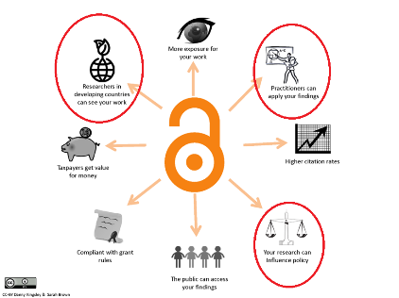
OS is good for research. Practicing Open Science means that research outputs are accessible to all – not stuck behind pay walls. This helps to ensure that all researchers have a level playing field - regardless of their location or economic situation. It means that the research process can be accelerated and new knowledge can be more quickly generated and built upon to help solve grand challenges.

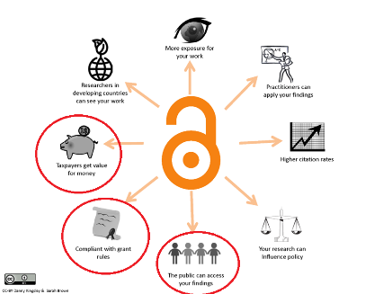

OS is good for society. OS offers a better return on investment from research funded by public money and contributes to better economic growth.

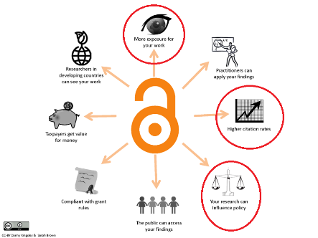
OS is good for you! Making your research outputs findable, accessible, interoperable and reusable (FAIR) does require some additional effort on your part but the good news is that practicing open science benefits you too. By publishing your data and code as well as your articles, you are essentially tripling the number of citable outputs for every project you work on. Your research will be more visible and understandable to others which can mean that you see your citation rate increase. If people can find and access your research, the potential impact of your research skyrockets. In addition, practicing OS can foster new collaborations and research partnerships that help to boost your esteem. All of which can help you to move forward in your career.

See if you are ready to put Open Science into practice by answering the following questions.

- Open Science relates to sharing research publications only. True or false?

- I should share my research outputs only when they have been published. True or false?

- Funding bodies expect researchers to share everything they produce in their research. True or false?

- Practicing Open Science only benefits others more than it benefits me as a researcher. True or false?

To take the quiz and claim a badge upon successful completion, access the course online at https://www.fosteropenscience.eu/learning/what-is-open-science/. Remember to log in first so you can claim your badge!

Additional resources

- ODI Data Essentials http://accelerate.theodi.org/#/
- European Data Portal eLearning Programme https://www.europeandataportal.eu/elearning/en/#/id/co-01
- Open Science Monitor https://ec.europa.eu/research/openscience/index.cfm?pg=home&section=monitor
- Open Science: one term, five schools of thought https://doi.org/10.1007/978-3-319-00026-8_2
- When will ‘Open Science’ become simply ‘science’? https://doi.org/10.1186/s13059-015-0669-2
- Open innovation, Open Science, open to the world - a vision for Europe https://ec.europa.eu/digital-single-market/en/news/open-innovation-open-science-open-world-vision-europe
- Do you speak Open Science? Resources and tips to learn the language https://doi.org/10.7287/peerj.preprints.2689v1
- Open innovation, Open Science, open to the world https://doi.org/10.2777/79895

Acknowledgements

These courses have been developed during 2018 as part of the FOSTER Plus (Fostering the practical implementation of Open Science in Horizon 2020 and beyond) project reusing openly available content produced by a range of content providers including DataOne, Research Data Netherlands, Open Data Institute, European Data Portal, Digital Curation Centre, UK Data Service, CESSDA ERIC, DARIAH, ELIXIR, Software Sustainability Institute, FOSTER and many others actively developing open educational resources relating to Open Science.

The courses are presented in a similar style to that employed by the Open Data Institute (ODI) and the European Data Portal in the hopes that this will enable our content to augment the body of Open Science related materials already produced and make their collective reuse more seamless. To this end, we have also made use of the Adapt authoring tool also used by the ODI and European Data Portal.
We have employed a variation of the case study approach developed by the European Commission's Open Science Monitor to help illustrate useful tools and initiatives from disciplinary perspectives.

Images used in the courses are under CC0 license unless otherwise stated.

https://youtu.be/7Kric3x7zr0
https://www.nature.com/collections/prbfkwmwvz/
https://peerj.com/preprints/2689/
https://www.fosteropenscience.eu/learning/managing-and-sharing-research-data
https://www.fosteropenscience.eu/learning/open-licensing
https://www.fosteropenscience.eu/learning/open-source-software-and-workflows/
https://www.fosteropenscience.eu/learning/open-licensing
https://www.fosteropenscience.eu/learning/open-access-publishing/
https://www.fosteropenscience.eu/learning/open-peer-review
https://www.re3data.org/
http://help.osf.io/m/registrations/l/524205-register-your-project
https://www.zooniverse.org/lab
https://orcid.org/
http://www.dcc.ac.uk/resources/how-guides/write-lay-summary
http://www.invo.org.uk/resource-centre/plain-english-summaries/
https://www.fosteropenscience.eu/learning/data-protection-and-ethics/
https://www.fosteropenscience.eu/learning/managing-and-sharing-research-data
FOSTER Plus https://www.fosteropenscience.eu/about. This project has also received funding from the European Union's Horizon2020 programme for research, technological development and demonstration under agreement no 741839.
https://www.dataone.org/
http://www.researchdata.nl/
https://theodi.org/
https://www.europeandataportal.eu/en/homepage
http://www.dcc.ac.uk/
https://www.ukdataservice.ac.uk/
https://www.cessda.eu/
https://www.dariah.eu/
https://www.elixir-europe.org/
https://software.ac.uk/
https://fosteropenscience.eu/
https://www.adaptlearning.org/
https://ec.europa.eu/research/openscience/index.cfm?pg=home&section=monitor

